Proforma for Affiliation to Haryana State Board of Technical Education
Bays 7-12, Sector-4, Panchkula-134112

1. To be filled by Existing Polytechnic Institutions offering diploma engineering program seeking extension of affiliation for 2018-19.
2. Please provide the actual information, if any information found false/incorrect may lead to disaffiliation of the Institute from HSBTE

INSTITUTE CODE: __116__

PART-A: GENERAL INFORMATION

Society / Trust / Company (U/S 25)
Name & Address of the Society / Trust / Company (U/S 25 of Companies Act, 1956): | ISHAR DEVI EDUCATIONAL AND CHARITABLE TRUST
Complete Postal address: | 521-L, MODEL TOWN, YAMUNA NAGAR, HARYANA
Society / Trust / Company Registration Number | 4304
Date of Registration / Place of Registration | 12/11/2007
Name of the Chairman / President of the Society / Trust / Company | Dr. K. L. Johar
STD code & Telephone No. (LL)  Mobile No. | 9313174001
Fax No. | 01731-268051
E-mail | vikramjohar@yahoo.com
Institution
Name of the Institution run by the Trust / Society / Company: | JAI POLYTECHNIC
Complete Postal address: | VILL & POST OFFICE ADHOI SHAHABAD BARARA ROAD TEH BARARA DISTT AMBALA
STD code & Telephone No. (LL)  Mobile No. | 01731-268051, 9466070479
Fax No. | 01731-268051
E-mail | mail@jaigroup.in
Type of the Institute (Write the appropriate one) | Private (Enclosed copy of Registration documents of Society/Trust) Please See Annexure-I
Year of starting of the Institute | 2008
Name of the Principal of the Institute | Dr. Arun Kapil
Qualifications | PhD
Date of Joining of the Institute | 14/08/2008
Contact Nos. (LL with STD Code /  Mobile No.) | 09466070479
E-mail | principal@jaigroup.in

PART-B: DETAILS OF THE LAND
(Attach copy of all the land documents / NOC’s)

Classification of the Permanent Site  (Please tick the applicable one & attach documents issued by the competent authority) |  | Mega / Metro | Urban |  | Non-Urban √
Town and Country Planning Dept. – Yes
Please See Annexure-II
 |  | Development Authority
 |  | State Revenue Authority
Land (Area in acres) |  | 5.19
Ownership of Land | Government |  |  | Trust √ |  | Society
(Please tick the applicable one) | Govt. Leased |  |  | Owned |  | Company (U/S 25)
Resolution of Society for use of ear marked Land for establishment of Polytechnic |  | Please See Annexure-I
No encumbrances certificate (contiguous-in single patch) | Please See Annexure-II
Change of Land Use Certificate (CLU) (Please tick the competent issuing authority & attach documents) | Town and Country Planning Dept.  Please See Annexure-III
 | Development Authority
 | Municipal Authority
 | Revenue Authority
Khasra Plan / Master Plan  (Please tick the competent issuing authority & attach documents) | Town and Country Planning Dept. √  Please See Annexure-III
 | Development Authority
 | Revenue Authority
Site Plan  (Please tick the competent issuing authority & attach documents) | Town and Country Planning Dept. √  Please See Annexure-IV
 | Development Authority
 | Revenue Authority
 | Municipal Authority
Building Plan  (Please tick the competent issuing authority & attach documents) | Total built-up area √ Please See Annexure-V
 | Development Authority
 | Revenue Authority
 | Municipal Authority
Occupancy certificate  (Please tick the competent issuing authority & attach documents) | Rural area: Tehsildar
Urban area: Municipal Corporation /
Municipal Committee /
HUDA
Structural stability certificate issued by Registered Structural Engineer  (applicable in case where occupancy certificate is more than 30 years old) | Yes Please See Annexure-VI
Access to the site (National Highway/ State Highway/ Village Road/ Kacha Road and Permission from competent authority to use | Yes Please See Annexure-IV
NOC from Local Fire Service Authorities (to ensure fire and life safety measures) | Yes
Whether Earth leakage circuit breaker (ELCB) provided? | Yes
Whether Ramp provided for Divyang for easy access to and evacuation from the building? | Yes
Whether any High tension electric line pass across the premises? | No

PART- C: APPROVAL STATUS OF THE INSTITUTE
(for the previous session; attach copy of all the approval/affiliation letters)
Approving authority | Letter Number | Date | Annexures
Copy of AICTE approval letter | F.No. North-West/1-3513397743/2018/EOA | 04-Apr-2018 | Please See Annexure-VII
Copy of PCI approval letter (if applicable) | Not Applicable
Copy of NCHMCT approval letter (if applicable) | Not Applicable
Copy of last affiliation letter of HSBTE | 15 | 15.05.2017 | Please See Annexure-VIII
Copy of NOC of State Government | Not Applicable

PART-D: ORGANIZATION, GOVERNANCE AND ADMINISTRATION

- Constitution of BOG with detailed qualification, experience of all the members
NOTE: 1. Provide the details of all the members as per Annexure –A
2. At least two meetings shall be held in a year. Please See Annexure-IX

Is BOG constituted as per AICTE/ PCI / HSBTE Norms. Yes
NAME AND ADDRESS OF THE MEMBERS OF THE GOVERNING BODY AS PER THE COMPOSITION PRESCRIBED BY AICTE
S. No | Name | Position | Qualification | Present Professional position / Occupation | Telephone Numbers | E-mail | Address
01. | Dr. K.L Johar | Chairman | M.A. PHD English | Chairman | 9416029209 | kljohar@rediffmail.com | 521-L, Model Town, Yamuna Nagar (Harayana)
02. | Sh. DR Johar | Vice-Chairman | PGDBM | Vice-Chairman | 9416020244 | johardaulat@yahoo.com | 150-Ar, Model Town, Yamuna Nagar (Haryana)
03. | Sh. Vikram Johar | Gen.  Secy. | B.Tech (Mechanical Engineering) | Managing Director, Protocols Surveyors & Engg. | 9313174001 | vikramjohar@yahoo.com | 239, Sector - 37, Noida (U.P.)
04. | Sh. Vivek Johar | Treasurer | B.Tech (Mechanical Engineering) | Director, Protocols Surveyors & Engg. | 9313174002 | vivekjohar@rediffmail.com | E-115, Sector-55, Noida (U.P.)
05. | Prof. Shakti Kumar | Members | M.Tech PHD (Computer Engineering) | Director IST, Kalawad ,Leading Educationist | 9896021400 | shaktik@gmail.com | HUDA, Sector 17, Jagadhri
06. | Prof. Jagmohan Singh | Members | M.Tech. (Computer Engineering) | Ex. Dean PAU. Ludhiana (Punjab) | 9812001836 | jagmohan08@gmail.com | PAU, Ludhiana (Punjab)
07. | Sh. SP Chopra | Members |  | Industrialist | 9416025721 |  | 3, Professor Colony, Yamuna Nagar
08. | Prof. M.C Verma | Members | PHD Business Management | Dean Faculty of Management, Hissar |  |  | Faculty of Management,JGU, Hissar
09. | Dr. Arun Kapil | Members | PhD | Principal | 9466070479 | principal@jaigroup.in | #335 Kapil Niwas Friends Colony, YamunaNagar
10. | Ms. Preeti Chhabra | Members | M.Tech (Computer Engineering) | Dept. of Computer Engineering | 9416452180 | academics@jaigroup.in | V.P.O. Adhoya Teh Barara Distt Ambala
Whether Anti-ragging committee (As per All India Council for Technical Education notified regulation for prevention and prohibition of ragging in AICTE approved technical Institutions vide No. 37-3/Legal/AICTE/2009 dated 01.07.2009) constituted, displayed in the campus of the institute and hoisted on the website of institute? YES
Whether Grievance Redressal Committee in the Institute. (As per All India Council for Technical Education (Establishment of Mechanism for Grievance Redressal) Regulations, 2012, F. No. 37-3/Lega112012, dated 25.05.2012) constituted, displayed in the campus of the institute and hoisted on the website of institute? YES
Whether Internal Complaint Committee (ICC) (As per section 4 of Sexual Harassment of Women at Workplace (Prevention, Prohibition and Redressal) Act, 2013) constituted, displayed in the campus of the institute and hoisted on the website of institute? YES
Whether Committee for SC/ST (As per the Scheduled Castes and the Scheduled Tribes (prevention of Atrocities) act, 1989, No. 33 of 1989, dated 11.09.1989) constituted, displayed in the campus of the institute and hoisted on the website of institute? YES
PART- E: STAFF STATUS & REQUIREMENT
Norms for Faculty requirements and Recommended Cadre Ratio for Diploma Level Technical Institution (for Diploma Engineering / Pharmacy Courses as per AICTE APH 2018-19)

 | Faculty :  Student  based on  Approved  Intake* | Principal/  Director | Head of the  Department | Lecturer | Total
 |  | A | B | C | D=A+B+C
Engineering and  Technology/ Architecture/  Planning/ Applied  Arts and Crafts,  HMCT | 1:25 | 1 | 1per  Department | (S/ 25) –  (A+B) | S/25
*Of which, a minimum of 80 % should be Regular/ full time faculty and the remaining shall be
Adjunct Faculty/ Resource persons from industry as per Annexure 10.
S = Sum of number of students as per “Approved Intake” at all years

The faculty details for all the 03 years for the various diploma courses being offered by the institute be elaborated course wise as per the AICTE APH 2018-19 (tabulated above) in the table given below:

NAME OF THE PRINCIPAL
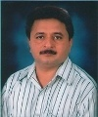  Stamp Size Photo | Date of Birth & Age | Qualification with Class obtained starting from the highest Degree | Corresponding Specialization | Date of Joining | Scale of Pay | Present Basic Pay | Total  emoluments | Aadhaar Number | Signature
 | 06-04-1967 50Years |  |  | 14.08.2008 | VI Pay | 75000 | 75,000 | 880446551123
 |  | PhD | Wireless Sensor Network

PRINCIPAL - EXPERIENCE
Teaching |  |  | Industry
Institution | Position | Years | Institution | Position | Years
JAI Polytechnic, Adhoi | PRINCIPAL | TILL DATE | NIL | NIL | NIL
JAI Polytechnic, Adhoi | H.O.D. | 1 | NIL | NIL | NIL
SJP Polytechnic, Damla | LECTURER | 18 | NIL | NIL | NIL

 |  |  |  |  | TEACHING FACULTY – QUALIFICATION
Faculty Member with Stamp Size Photo |  |  | Name of the Faculty Member | Designation |  | Department | Qualification with Class obtained starting from the highest Degree | Corresponding Specialization | Date of Birth & Age | Date of Joining | Experience | Scale of Pay | Present Basic Pay | Total  Emoluments | Aadhaar Number | Signature
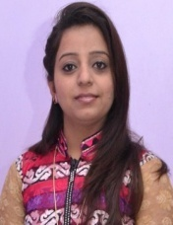 |  |  | PREETI CHHABRA | HEAD OF DEPT |  | COMPUTER ENGINEERING | M.Tech | COMP | 26-08-1987 | 23-08-2008 | 9.5 Years | V1TH PAY | 33,000 | 33,000 | 983115525530
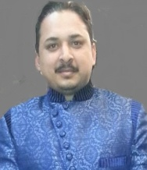 |  |  | DEEPAK SHARMA | HEAD OF DEPT |  | APPLIED SCIENCE | M.SC | MATHS | 11-08-1981 | 24-7-2009 | 9 Years | V1TH PAY | 21,300 | 21,300 | 461244451343
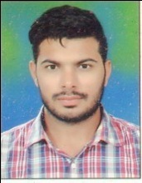 |  |  | MANGAT RAM | HEAD OF DEPT |  | MECHANICAL ENGINEERING | B.TECH | MECH | 05-12-1989 | 03-08-2015 | 7 Years | Consolidated | 20,000 | 20,000 | 967797209283
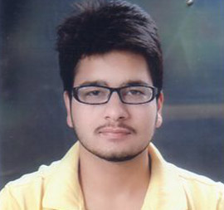 |  |  | ROBIN BAJAJ | HEAD OF DEPT |  | CIVIL ENGINEERING | B.TECH | CIVIL | 20/1/1995 | 15/9/2016 | 2 Years | Consolidated | 15,600 | 15,600 | 547756528230
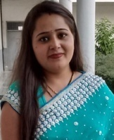 |  |  | NEHA SHARMA | LECTURER |  | COMPUTER ENGINEERING | B.TECH | COMP | 04-02-1995 | 25-08-2015 | 1.6 Years | Consolidated | 15,600 | 15,600 | 299184026705
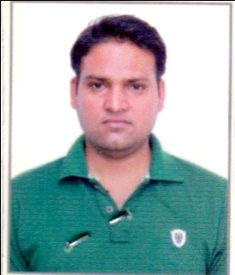 |  |  | ANIL KUMAR | LECTURER |  | CIVIL ENGINEERING | B.TECH | CIVIL | 29/11/1986 | 17-08-2017 | 5 Years | Consolidated | 15,600 | 15,600 | 217125341694
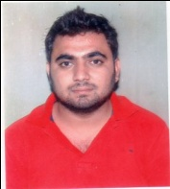 |  |  | NITISH PAHWA | HEAD OF DEPT |  | CIVIL ENGINEERING | B.TECH | CIVIL | 11-12-1989 | 21-01-2015 | 5 Years | Consolidated | 15,600 | 15,600 | 551217415142
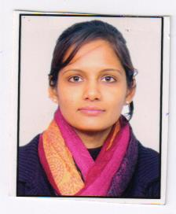 |  |  | SANGEETA RANI | LECTURER |  | COMPUTER ENGINEERING | B.TECH | COMP | 04-04-1989 | 02-12-2012 | 4.5 Years | Consolidated | 15,600 | 15,600 | 510875752721
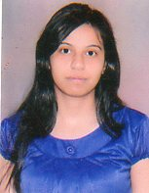 |  |  | RESHU MEHNDIRATTA | LECTURER |  | ELECTRICAL ENGINEERING | MBA | MBA | 15-06-1992 | 14-09-2015 | 1.6 Years | Consolidated | 15,600 | 15,600 | 591971272517
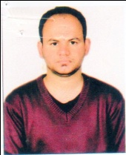 |  |  | BHUVAN JOSHI | LECTURER |  | MECHANICAL ENGINEERING | B.TECH | MECH | 07-07-1987 | 27-01-2015 | 6 Years | Consolidated | 17,500 | 17,500 | 863057343154
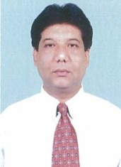 |  |  | WENDELL JOSEPH LOBO | LECTURER |  | CIVIL ENGINEERING | B.TECH | CIVIL | 18/05/1965 | 01/02/2016 | 6Years | Consolidated | 7,000 | 7,000 | 556007977862
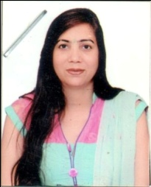 |  |  | POOJA KALRA | LECTURER |  | APPLIED SCIENCE | M.A. | COMM SKILLS | 30-07-1981 | 01-02-2018 | 5 YEARS | Consolidated | 15,600 | 15,600 | 557272104573
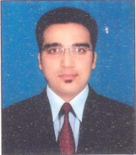 |  |  | ABHISHEK KUMAR | LECTURER |  | COMPUTER ENGINEERING | B.TECH | COMP | 01-01-1991 | 01-02-2016 | 4Years | Consolidated | 7,000 | 7,000 | 920068492285
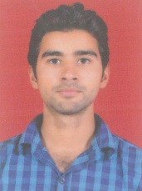 |  |  | VAIBHAV SHARMA | LECTURER |  | ELECTRICAL ENGINEERING | B.TECH | ELECT | 05-02-1990 | 01-02-2016 | 4 Years | Consolidated | 7,000 | 7,000 | 559436825891
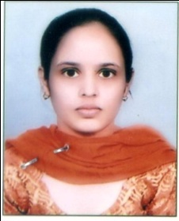 |  |  | MANJEET KAUR | LECTURER |  | MECHANICAL ENGINERRING | B.TECH | COMP | 29/2/1992 | 17-08-2017 | 6 MONTHS | Consolidated | 15,600 | 15,600 | 754376849606
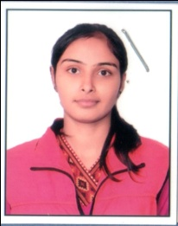 |  |  | DIVYA SAINI | LECTURER |  | COMPUTER ENGINEERIN | B.TECH | COMP | 2/11/1995 | 01-08-2017 | 6 MONTHS | Consolidated | 15,600 | 15,600 | 305711723741
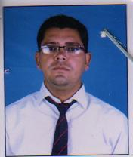 |  |  | MUNISH KUMAR | LECTURER |  | ELECTRICAL ENGINEERING | MBA | HR | 21/101984 | 10/2/2014 | 3 Years | Consolidated | 7,000 | 7,000 | 673710777907
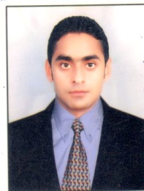 |  |  | SAHIL CHAWLA | LECTURER |  | ELECTRICAL ENGINEERING | B.TECH | IT | 20/7/1986 | 10/2/2014 | 3Years | Consolidated | 7,000 | 7,000 | 365422634677
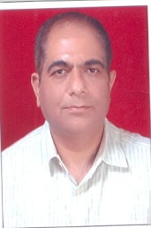 |  |  | VIVEK JOHAR | LECTURER |  | MECHANICAL ENGINEERING | BTECH | MECH | 17-0-9-1969 | 01-02-2016 | 17 Years | Consolidated | 8,000 | 8,000 | 519099256958
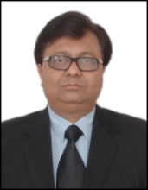 |  |  | DAVINDER KUMAR GULATI | LECTURER |  | MECHANICAL ENGINEERING | BTECH | MECH | 01-09-1964 | 01-02-2016 | 17 Years | Consolidated | 8,000 | 8,000 | 669464607582
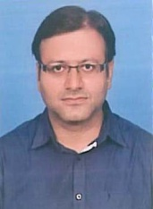 |  |  | SUMIT KUMAR | LECTURER |  | MECHANICAL ENGINEERING | DIPLOMA | MECH | 01-01-1981 | 01-02-2016 | 6 Years | Consolidated | 8,000 | 8,000 | 748145158406
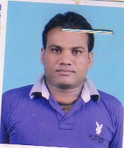 |  |  | PARVEEN NEGI | INSTRUCTOR |  | ELECTRICAL ENGINEERING | DIPLOMA | ELECT | 19-01-1978 | 14-01-2015 | 5 Years | Consolidated | 17,500 | 17,500 | 323644046485
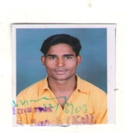 |  |  | AAVIDH KHAN | LECTURER |  | CIVIL ENGINEERING | B. Tech | CIVIL | 18-02-1990 | 03-03-2012 | 6.5 Years | Consolidated | 15,600 | 15,600 | 446601508081
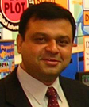 |  |  | BHASKAR MOOKHERJEE | TPO |  | CIVIL ENGINEERING | B.SYS ADMIN | COUNCELL | 28-09-1968 | 01-03-2012 | 6 Years | VITH PAY | 15,600 | 15,600 | 247082107798
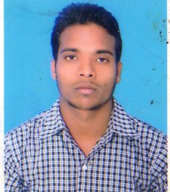 |  |  | TINU KUMAR | LECTURER |  | MECHANICAL ENGINEERING | B.TECH | MECH | 14-08-1989 | 22-08-2016 | 5 years | CONSOLIDATED | 15,600 | 15,600 | 220165331005
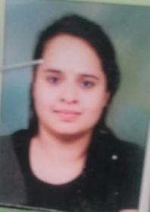 |  |  | HIMANI | LECTURER |  | ELECTRICAL ENGINEERING | B.TECH | ELECT | 06-04-1994 | 27-02-2017 | 2 year | CONSOLIDATED | 15,600 | 15,600 | 311073306543
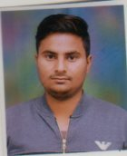 |  |  | VAIBHAV | LECTURER |  | CIVIL ENGINEERING | B.TECH | CIVIL | 10-11-1993 | 06-02-2017 | 2 year | CONSOLIDATED | 15,600 | 15,600 | 787108248722
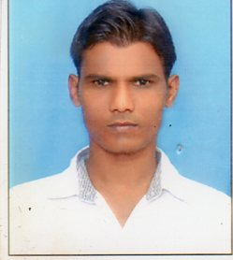 |  |  | SUBHASH | H.O.D. |  | ELECTRICAL ENGINEERING | B.TECH | ELECT | 18-12-1987 | 02-08-2016 | 3 years | CONSOLIDATED | 15,600 | 15,600 | 297142252784
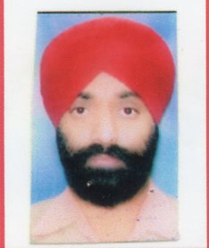 |  |  | SHAMSHER SINGH | INST |  | MECHANICAL ENGINEERING | ITI | MECCH | 30-09-1968 | 24-08-2016 | 6 YEARS | CONSOLIDATED | 15,600 | 15,600 | 758992944078

 | LIBRARIAN AND PHYSICAL EDUCATION DIRECTOR
Name with Stamp Size Photo |  | Name | Designation | Qualification with Class obtained starting from the highest Degree | Previous Experience | Date of Birth & Age | Date of Joining | Scale of Pay | Present Basic Pay | Total  Emoluments | Aadhaar Number | Signature
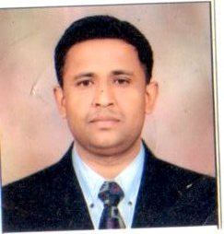 |  | SUBHASH SHARMA | Librarian | M.LIBRARY SCIENCE, M.A.(SOCIOLOGY),M.A(HINDI) | 8.5 years | 25/10/1979 | 8/7/2008 | Consolidated | 16100 | 16100

WORKSHOP AND TECHNICAL SUPPORTING STAFF
PLEASE SEE ANNEXURE X
S.  No | Name of the Staff | Department | Laboratory | Designation | Qualification | Previous Experience | Date of Birth & Age | Date of Joining | Scale of Pay | Present Basic Pay | Total  emoluments | Aadhaar Number | Signature

MINISTERIAL STAFF
PLEASE SEE ANNEXURE XI
S.  No | Name of the Staff | Place of Work | Designation | Qualification | Previous Experience | Date of Birth & Age | Date of Joining | Scale of Pay | Present Basic Pay | Total  emoluments | Aadhaar Number | Signature

PART F: INFRASTRUCTURAL FACILITIES
Norms for Land requirement and built-up area for Diploma Level Technical Institution (for Diploma Courses as per AICTE APH 2018-19)

PHYSICAL INFRASTRUCTURE - COMPLETE DETAILS OF BUILT-UP AREA
S.  No | Built-up (Carpet) Area | FIRST YEAR , SECOND YEAR & THIRD YEAR
 |  | Type of Structure [RCC/ACC] | Required Area  [sq.m] as per AICTE | Available Area  [sq.m] | Shortfall, if any
(a) | Instructional area [INA] | RCC |  | 6261
(b) | Administrative area [ADA] | RCC |  | 809
(c) | Amenities area [AMA] | RCC |  | 1969
(d) | Circulation area [CIA] | RCC |  | 2012
[CIA = 0.25 x (INA+ADA+AMA)] |  | TOTAL AREA : | TOTAL AREA : | 11051 | NIL

ADMINISTRATIVE AREA REQUIREMENT FOR DIPLOMA COURSES
Particulars | Number of rooms required | Minimum Carpet Area required | Carpet Area available | Shortfall w.r.t. Number of Room & Carpet Area
Principal / Director room | 01 | 30 sqm | 35 | NIL
Board room | 01 | 20 sqm | 70 | NIL
Office all inclusive | 01
 | Campus having one program | 150 sqm | 235 | NIL
 | Campus having more than one program | 300 sqm |  | NA
Department offices | 01/Deptt. | 20 sqm | 100 | NIL
Cabins for HOD’s | 01 | 10 sqm | 60 | NIL
Faculty rooms | - | 30 sqm (subject to minimum 5 sqm for each faculty member) | 110 | NIL
Central stores | 01 | 30 sqm | 30 | NIL
Maintenance Room | 01 | 10 sqm | 18 | NIL
Security Room | 01 | 10 sqm | 22 | NIL
Housekeeping Room | 01 | 10 sqm | 18 | NIL
Pantry for staff (Desirable) | 01 | 10 sqm | 36 | NIL
Examination control office (Confidential Room) | 01 | 30 sqm | 35 | NIL
Placement office | 01 | 50 sqm | 50 | NIL

IMPORTANT INFRASTRUCTURE REQUIREMENT FOR DIPLOMA COURSES
Particulars | Number of rooms required | Minimum Carpet Area required | Carpet Area available | Shortfall w.r.t. Number of Rooms & Carpet Area
Computer Centre | 01 | 150 sqm | 150 | NIL
Library and Reading Room | 01 | 400 sqm | 400 | NIL
Seminar Hall | 01 | 132 sqm | 140 | NIL
Smart class room | 01 | 66 sqm | 70 | NIL
Language laboratory | 01 | 70 sqm | 70 | NIL

INFRASTRUCTURE REQUIREMENT FOR DIPLOMA COURSES IN ENGG.
Particulars | Number of rooms required | Number of rooms available | Minimum Carpet Area required | Carpet Area available | Shortfall w.r.t. Number of Rooms & Carpet Area
I | II |  | III | IV | V
Lecture Rooms | Number of divisions of engg. course X duration of course |  | 66 sqm each room | 1607 | NIL
Tutorial Rooms | Lecture rooms / 04 |  | 33 sqm each room | 210 | NIL
Total no. of Labs for (Diploma Engg. Courses  Laboratories for the 1st year includes Physics and Chemistry Laboratory each of 66 sqm are required) | 05 / course |  | 66 sqm each lab | 2265 | NIL
Workshop for all courses | 01 |  | 200 sqm | 499 | NIL
Additional Workshop (for category “X” courses)  Category X of Courses: Mechanical, Production, Civil, Electrical, Chemical, Textile, Marine, Aeronautical and allied Courses of each. | 02 / course  (Maximum 04) |  | 800 sqm | 800 | NIL
Drawing Hall | 01 |  | 132 sqm | 140 | NIL

BASIC AMENITIES FOR DIPLOMA COURSES
Toilets (Ladies & Gents) | 01 | 150 sqm  (Campus having one program) | 193 sqm | NIL
350 sqm
(Campus having more than one program)
Toilets for Divyang | 01 | --- | 01 | NIL
Girls Common Room | 01 | 75 sqm | 75 sqm | NIL
Boys Common Room | 01 | 75 sqm | 75 sqm | NIL
Canteen/cafeteria (Desirable) | 01 | 150 sqm | 150 sqm | NIL
First aid-cum-sick room | 01 | 10 sqm | 16 sqm | NIL
Drinking water facility (water cooler) essential | Adequate nos. (with attached water purifiers) | -- | Adequate | NIL
Principal’s Quarters | Desired | 150 sqm |  | NA
Guest House | Desired | 30 sqm |  | NA
Sports Club / Gymnasium / Playground | Desired | 200 sqm |  | NA
Auditorium / Amphi Theater | Desired | 400 sqm |  | NA
Boys Hostel | Desired | Adequate | 1450 sqm | NIL
Girls Hostel | Desired | Adequate |  | NA

COMPUTERS, SOFTWARE, INTERNET AND PRINTERS
Program | Number of  PCs/  Laptops to  students  ratio  (Min 20 PCs) | Legal  System  Software | Legal  Application  n Software | LAN and  Internet | Mail  Server and  Client | Printers including  Color Printer (% of  total number of  PCs/ Laptops)
Engineering/  Technology | 240 | 3 | 22 | ALL | Desired | 24
Engineering/  Technology | 1:6 | 03 | 20 | All | Desired | 5%
HMCT | 1:6 | 01 | 10 | All | Desired | 5%
NOTE:
- At least 4Mbps Wi-Fi connectivity at 4 or 5 hotspots shall be made available.
- Library, Administrative offices and Faculty members shall be provided with exclusive computing facilities along with LAN and Internet. This shall be considered as over and above the requirement meant for PCs to student’s ratio.
- Every department shall have separate computer Laboratory with at least 20 computers. A centralized computer Laboratory with at least 100 computers.

BOOKS, JOURNALS AND LIBRARY FACILITIES
Program | Total number of  Divisions | Titles | Volumes | National Journals | Reading Room  Seating | Multimedia PCs for  Digital Library/  internet Surfing  located in reading  room
 |  | Number |  |  | Percentage of total students
Engineering and  Technology | 6 | 1310 | 18153 | 18 | 150 | 10
Engineering and  Technology | B | 50# | 250xB# | 3xB# | 15 % (Max 150) | 1 % (Max 10)
 |  | 25 per*  Course | 125  per*Course
HMCT | B | 50# | 250xB# | 3xB#
 |  | 25 per*  Course | 125  per*Course
NOTE:
- B=Number of divisions at 1st year (Shift 1+2) + Number of 2nd year direct divisions (Shift 1+2)
- #Book titles and volumes required at the time of starting new Institution.
- Total numbers of titles and volumes shall be increased in continuation till 15 years, which shall be the minimum stock of books. However, Institutions shall have to add annual increment of books as specified in Approval Process Handbook 2018-19.
- *Annual increment.
- Digital Library facility with multimedia facility is essential.
- Reprographic facility in the library is essential.
- Document scanning facility in the library is essential.
- Library books/ non books classification as per standard classification methods is essential.
- Availability of NPTEL facility at the library is essential.

ESSENTIAL AND DESIRABLE REQUIREMENTS AS PER AICTE APH 2018-19
Sr. No | Description | Availability  [YES / NO] | Details to be provided.  [Number,  if so required]
Essential Requirements
 | Standalone Language Laboratory | YES
 | Potable Water supply and outlets for drinking water at strategic locations | YES
 | Electric supply | YES
 | Sewage Disposal system | YES
 | Telephone | YES
 | Vehicle parking | YES
 | Display of information submitted to AICTE (including the accreditation status and Board of Governors) along with mandatory disclosures in the Web site of the Institution. | YES
 | Copies of AICTE approvals (LoA and EoA of subsequent years) obtained since  inception of the Institution till date shall be placed in the web site of the Institution | YES
 | Digital payment for all financial transactions as per MHRD directives | YES
 | Provision to watch MOOCS courses through Swayam | NA
 | Display board within the premises as well as in the web site of the of Institution indicating the Chairman / President of the Trust of the institute, faculty available, facilities offered / available at the institute and feedback facility of students | YES
 | Implementation of Unnat Bharat Abhiyan | YES
 | Barrier Free Built Environment for disabled and elderly persons including availability of specially designed toilets for ladies and gents separately (as per Chapter V of Approval Process Handbook 2018-19). | YES
 | Safety and Security measures in the Campus (as per Chapter V of Approval Process Handbook 2018-19 and Safety Guidelines issued by Department of Technical Education, Haryana) | YES
 | Safety provisions including fire and other calamities (Refer Annexures 8 and 9 of Approval Process Handbook 2018-19) | YES
 | Implementing Food Safety and Standards Act, 2006 in the Institution | YES
 | General Insurance provided for assets against fire, burglary and other calamities | YES
 | All weather approach road suitable for use by Motor vehicle- Motorized Road | YES
 | General Notice Board and Departmental Notice Boards | YES
 | First aid, Medical and Counseling Facilities | YES
 | Appointment of Student Counselor | YES
 | Group Insurance to be provided for the employees | YES
 | Insurance for students | YES
 | Institution-Industry Cell | YES
 | Placement Cell | YES
 | Applied for membership of National Digital Library | YES
 | Strong Room [Storing QPs & ASs] | YES
 | Security arrangement [Day / Night] | YES
 | Sufficient halls for Examination | YES
Desirable Requirements |  |  |  |  | Desirable Requirements
 | Implementation of the schemes announced by MHRD | NA
 | Offering of Skill development Courses approved by the Council | NA
 | Participation in the National Institutional Ranking Framework (NIRF) | NO
 | Fabrication facility Laboratory (FABLAB)/ Tinkering Laboratory/ Innovation  Laboratory | NO
 | Backup Electric Supply | YES
 | Availability of at least ONE Smart Classroom per Department | YES
 | Rain Water Harvesting and installation of grid connected solar rooftops/ Power Systems | YES
 | Waste management and environment improvement measures to ensure a sustainable Green Campus | YES
 | Public announcement system at strategic locations for general announcements/ paging and announcements in emergency. | YES
 | Enterprise Resource Planning (ERP) Software for Student-Institution-Parent interaction | YES
 | Transport | NO
 | Post, Banking Facility/ ATM | NO
 | CCTV Security System | YES
 | LCD (or similar) projectors in classrooms | YES
 | Staff Quarters | NO
 | Display of Courses and “Approved Intake” in the Institution at the entrance of the Institution. Courses taken through duly recognized MOOCs shall be used as Supplementary Courses. | YES
 | Implementation of Unnat Bharat Abhiyan/ Saansad Adarsh Gram Yojana (SAGY) | NO
 | Implementation of Startup Policy | NO
 | Intellectual Property Right Cell | NO
 | Availability of quality sanitary napkins through sanitary napkin vending machines and ensuring safe and environment friendly disposal of used sanitary napkin through sanitary napkin incinerator | NO

PART G – DETAILS OF MACHINERY/ EQUIPMENT
MACHINERY/EQUIPMENTS
1. | Whether Machinery/Equipments for all the Laboratories / Workshops as per the syllabus prescribed by HSBTE available? | YES
2. | Whether all the existing Machinery/Equipments are entered in Stock Register? | YES
3. | Whether all the existing Machinery/Equipments are in working condition or not ? | WORKING
4. | If not, list out the Machinery/Equipments that are not in working condition | NA
5. | Whether any Machinery/Equipments are likely to be purchased in respect of the Courses for which extension of approval is applied | NO
6. | If YES, list out the Machinery/Equipments | NA
NOTE:
Course wise list of equipments and its adequacy as per the syllabus prescribed by HSBTE [for a batch of 30 students] be annexed for all the diploma courses being offered by the institute

PART H – FINANCIAL & PHYSICAL RESOURCES
Budgeted Expenditure for the year 2017-18
Expenditure Heads | Budget  (In lakhs) | Actual Expenditure | Shortfall if any
I. Academic Buildings:
- Construction
- Maintenance Expenses
II. Laboratories/Computing Centre
- New Equipment
- Furniture
- Operation & Maintenance
III. Salary
- Salary of Teaching Staff
- Salary of Non-Teaching Staff
IV. Faculty/Staff Development
(Seminars/Workshops/Incentive Schemes/Training/Higher Studies)
V. Library
- Books
- Journals ,e-journals
- E-library
VI. Services
- Administration/Transport/Hostels/Canteen/Security/Water/Electricity/P&T:
- Hostel Maintenance
- Landscaping
- Internet facility
VII. Students Activities
- Extracurricular/Co-curricular/
Sports/Cultural /extra classes
VIII. Medical Expenses
-Full time or otherwise
IX. Any Other, please specify

Latest Balance Sheet of the Society certified from CA is to be attached.
PLEASE SEE ANNEXURE -XII

PART I – STUDENT RELATED INFORMATION
Academic Performance of Last three Years (Attach Annexure if required)
PLEASE SEE ANNEXURE -XIII
S. No. | Course | Year | Sanctioned intake | No. of students admitted | Number of students Appeared in Board Exams | Students Passed | Passed with 1st Division | Pass Percentage
 |  |  |  |  | A | Number (B) |  | (B/A)*100
1. |  | 1st year
 |  | 2nd year
 |  | 3rd year
Up keep of Attendance Record of Students
S. No. | Course / with year/ Semester | Hours of teaching from start of session | Total students on roll | Number of students |  |  |  | Remarks
 |  |  |  | Above 75% | Above 70% | Above 65% | Above 60%
1. | Civil/2nd | 40 hrs per week | 18 | 8 | 7 | 3 | 0
2. | Comp/2nd | 40 hrs per week | 12 | 5 | 5 | 2 | 0
3. | Elect/2nd | 40 hrs per week | 10 | 4 | 4 | 1 | 1
4. | Mech/2nd | 40 hrs per week | 11 | 4 | 5 | 1 | 1
5. | Civil/4th | 40 hrs per week | 27 | 15 | 9 | 2 | 1
6. | Comp/4th | 40 hrs per week | 17 | 7 | 7 | 2 | 1
7. | Elect/4th | 40 hrs per week | 26 | 14 | 8 | 3 | 1
8. | Mech/4th | 40 hrs per week | 42 | 25 | 13 | 3 | 1
9. | Civil/6th | 40 hrs per week | 34 | 19 | 12 | 2 | 1
10. | Comp/6th | 40 hrs per week | 8 | 3 | 2 | 2 | 1
11. | Elect/6th | 40 hrs per week | 19 | 10 | 7 | 1 | 1
12. | Mech/6th | 40 hrs per week | 44 | 26 | 14 | 3 | 1

Details:
- Merit position/toppers branch wise in the HSBTE Exams, if any.
PLEASE SEE ANNEXURE XIV
- Awards awarded by the Polytechnic to the academic toppers of the Polytechnic.
PLEASE SEE ANNEXURE XV
- Steps taken for improving the academic results.
- Emphasis is being laid on practicals for better understanding of the subjects.
- Implementation of Audio-video modules
- Students are being motivated to give seminars in the classes.
- Extra classes are being organized and class tests have been increased.
- Industrial tours have been organized to provide learning experience of industries.
- Conduct of extra classes for weak/ needy students
Extra Classes of Communication Skills are being conducted. Saturday is declared as working day for weak students in order to improve their academics.
- Total no. of working days observed in Semester PLEASE SEE ANNEXURE XVI
- Whether Alumni association is formed or not. YES
- Efforts made for quality teaching/ improving pedagogy/ personality development & improvement in Communication Skill of students.
- E-Learning Modules: The E-LEARNING Modules has been set up which imparts knowledge with the visualization of both practical as well as theoretical concept to provide quality teaching.
- Personality Development: Extension lectures had been delivered to the students to improve their personality and their communication skills.
- Spoken English: Lectures by expert are given to students for improvement of spoken English.
- Presentations: Presentations by students to develop their communication skills.
- Debates & Declamation Contest: These types of contests are organized in order to improve the level of confidence of the students.

- Steps taken for improving academic ambiance of the Polytechnic like land scaping, horticulture, tree plantation etc. With the help of Gardener and students trees/plants are being planted on college land.
- Utilization of student fund for student welfare activities.
- Purchase of equipments for various sports/games.
- Helping to students through fee concession.
- Organization of various competitions like quiz, Poster Making Competitions, declamation contest and debates.
- Organization of Blood Donation Camps

- Teaching-Learning process:
  - Whether Academic Calendar implemented? Yes
  - Whether Teaching Aids used? Yes
  - Whether Student Feedback implemented? Yes
  - Any new innovation/ practice / technique adopted in teaching? Yes
  - Whether Teacher’s Diary maintained? Yes
Industry Institution Interaction & Placements
(a) Mention the following details if any.
- Details of industrial tours/visits/ seminar etc. organized in the previous academic session
Industrial visit to different companies /Industries helped the students regarding practical knowledge of the subject .Number of Industries has been visited by the students like MARS Infotech, 66 KV Substation , Dainik Jagran, Hathni Kund Chail (H.P.), Communication Tower at Kasauli, Godawari Foundary, Luminous Pvt Ltd, Baddi and many more in the list

- Consultancy NO
- Industrial Project Work NO
- Seminars/Conferences/Lectures with industry partnership
Number of lectures delivered to students by different concerned persons like Dr. Divyani Singh delivered lecture on personality development, Tech Mahindra Consultant, training lectures by ICA group, Manager of Protocol Surveyor Pvt. Ltd & lectures are also delivered by experts of AutoCad to teach Mechanical & Civil students and many more. Lectures on how to make projects were delivered to ECE students by Agile Enterprises. Seminars on how to increase confidence and Personality including how to become business oriented and successful person

(b) Student’s Placement:
- Whether training and placement cell has been established? Yes
- Name of the Training and Placement Officer Mr Bhaskar Mookherjee
- Qualification and Experience of Training and Placement Officer B. SYS ADMIN
- Number of companies which visited the Institute during the last three years for campus interviews (Please supply the list of companies) & efforts made for improving Industrial Institution Interaction. PLEASE SEE ANNEXURE XVII
- Number of extension lectures delivered by outside experts during the last three years 15
- Course wise number of students placed during the last 3 years:
PLEASE SEE ANNEXURE XVII

Course | No. of Eligible Students | No. of Students Placed | Percentage

Extra Curricular Activities
Brief account of the activities/ achievements of the Institute during the previous year:
- Games and sports
- Students participated at local level in different tournaments like cricket, volleyball, Badminton and many more.
- Students won Semifinal in Football team at inter college level

- Debates/ Paper presentation / Quiz Competitions etc.
- Students won many prizes in these competitions at various colleges in polytechnic as well as engineering colleges. College always takes these types of steps in order to encourage students.
- Cultural activities
- Number of activities was held at college level like talent show, Annual Function and prize distribution Function

- NCC/NSS NA
- Students help desk
- A Counsellor set has been provided in the college in which some staff members and students of final year provided the help to the students in the field of selection of company opting for a trade, various professional courses and regarding project also.

- Any other
- A Cricket, Table Tennis, Chess and Football Tournament was organized at college level in which many students participated. Trophies were awarded to the winners.
- 25 number of students stood merit position in the results announced by DTE 2017-18
- Recently our Polytechnic organized a blood donation camp on March 30, 2018 where as many as 100 students and members of staff donated blood Male and female students vied with one another to be among the first to donate blood.

PART J – FACULTY DEVELOPMENT INITIVATIES
- Number of faculty sponsored by the institute since its inception to till date for improvement of academic qualification teaching skills etc. 15
- Number of faculty sponsored to attend training conference and other professional meeting within and outside the country and the total amount spent for this purpose by the Institute/ Trust/ Society. 5
- Number of faculty sponsored for industrial training. 5
- Does the institute possess any faculty development plan, if so give the details.
As per faculty development plan few staff members will join the course /training at NITTTR Chandigarh and many other places.

PART K – OTHERS
  - Please state whether the applicant is running and / or managing any other technical / professional institution which is approved in the premises on sharing basis. If so, please give the name of the programs / courses being conducted. No
  - Whether the applicant has any Court Case in respect of violation of provisions of State Govt. / UGC or that of any other statutory body including AICTE / NCHMCT / PCI. No
  - Has the institute ever been served show cause notice by the Board for indulging in malpractices in conduct of Board examination? If Yes, Please mention the details and its present status. No
  - Has the institute ever been served show cause notice by the DTE / AICTE / PCI / NCHMCT / HSBTE for indulging in malpractices / violation of rules, etc? If Yes, Please mention the details and its present status. No
  - Please submit status of compliance in respect of various conditions / guidelines as per latest AICTE approval Letter.
  - Please submit status of compliance in respect of Grievance Redressal Committee for students as notified by AICTE. PLEASE SEE ANNEXURE XVIII
  - Please submit status of compliance in respect of various conditions / guidelines as per latest DTE / State Govt. NOC. NA
  - Whether any deficiencies were reported by the AICTE during last two years? If Yes, Please submit the compliance of these deficiencies. PLEASE SEE ANNEXURE XIX
  - Whether any deficiencies were reported by the DTE / HSBTE during last two years? If Yes, Please submit the compliance of these deficiencies. No
  - Please describe briefly future plans for improvements in infrastructure / expansion in academic and other activities to fully meet the norms and standards.
    - Advance kits for practice are to be purchased & also to increase the number of kits.
    - Planning to open excellence centers in the field of Mechanical, Electrical and Civil Engineering.
    - Collaboration with Industries (IIIC) to give on-site training and handling of Projects.
    - Planning’s are in process in order to make Campus Wi-Fi.

Name and Signature of the Principal /
Director of the Institution.

Counter signed by:

(Chairman / President of the Society / Trust / Board) | (Two Members on Society/Trust/Board)

Annexure-A

MEMBER /INDIVIDUAL DETAILS

Details of the Individuals/ members/office bearers of organization
Affix latest passport size photo
- Name............................................................

- Father Name............................................................

- Designation in the Trust/Society/Mission/Company etc..

.............................................................................................

- Permanent Address.............................................................

............................................................................................

- Correspondence Address.....................................................

.............................................................................................

- E-Mail ID........................................................................

- Occupation.........................................................................

- Qualification Details.............................................................

- Telephone/Mobile Number/FAX Number.......................................

- Work place address........................................................................

- Pan Number.........................................................................

- Aadhar Number.........................................................................

- DIN Number..........................................................................

Note:-Information regarding all the members as per the constitution of the Society/Company/Trust/etc. have to be provided. This is to be filled up by each member separately.

Date:
Place: (Signature)

